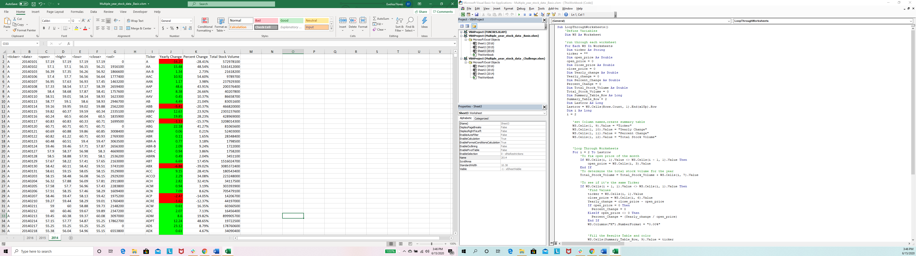

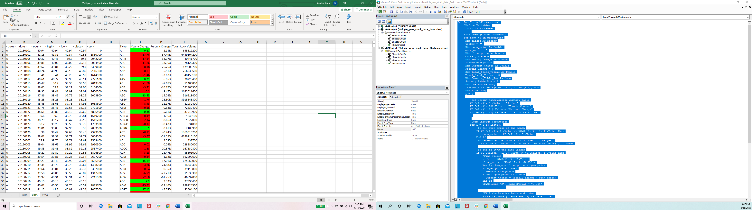

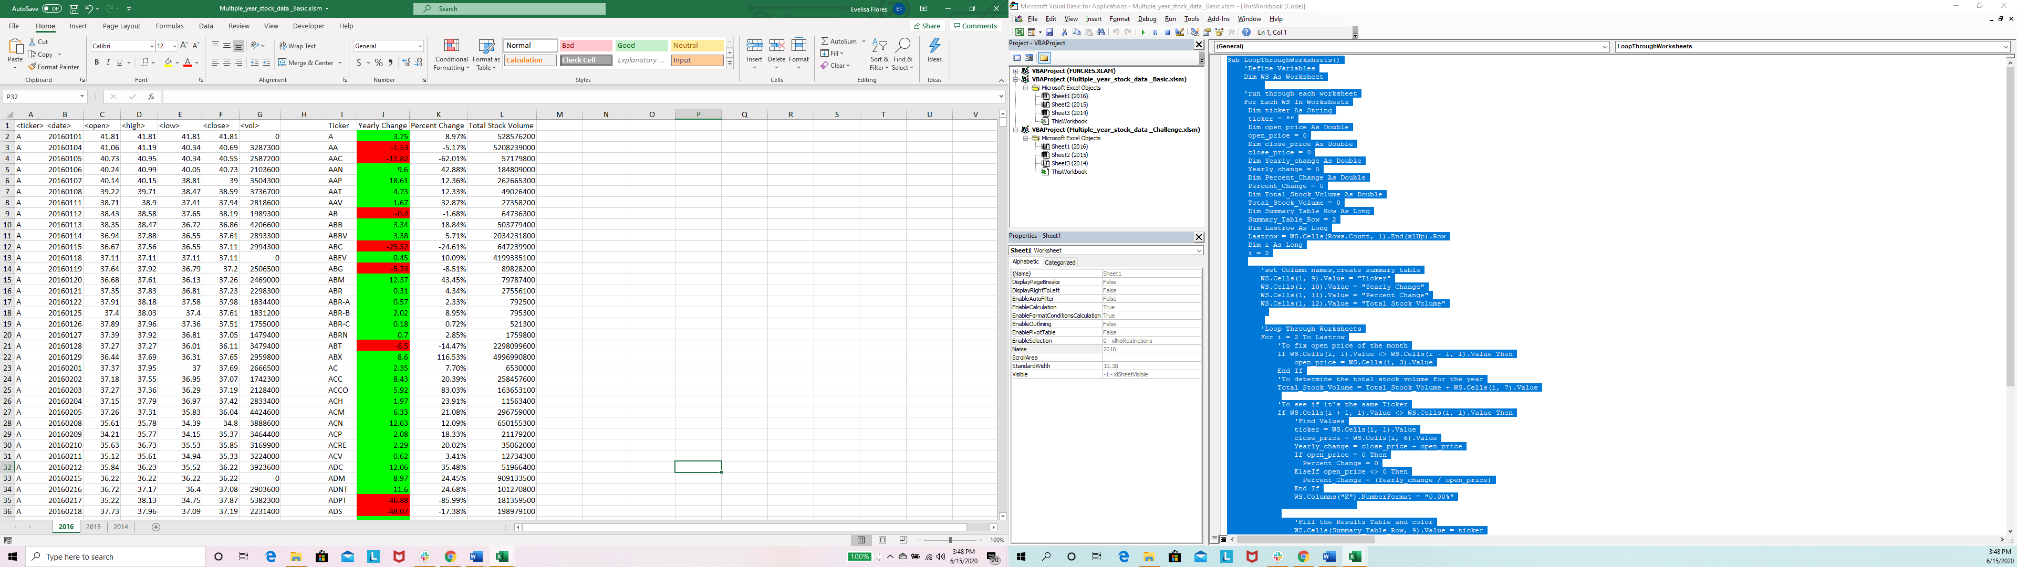

BASIC SCRIPT

Sub LoopThroughWorksheets()

'Define Variables

Dim WS As Worksheet

'run through each worksheet

For Each WS In Worksheets

Dim ticker As String

ticker = ""

Dim open_price As Double

open_price = 0

Dim close_price As Double

close_price = 0

Dim Yearly_change As Double

Yearly_change = 0

Dim Percent_Change As Double

Percent_Change = 0

Dim Total_Stock_Volume As Double

Total_Stock_Volume = 0

Dim Summary_Table_Row As Long

Summary_Table_Row = 2

Dim Lastrow As Long

Lastrow = WS.Cells(Rows.Count, 1).End(xlUp).Row

Dim i As Long

i = 2

'set Column names,create summary table

WS.Cells(1, 9).Value = "Ticker"

WS.Cells(1, 10).Value = "Yearly Change"

WS.Cells(1, 11).Value = "Percent Change"

WS.Cells(1, 12).Value = "Total Stock Volume"

'Loop Through Worksheets

For i = 2 To Lastrow

'To fix open price of the month

If WS.Cells(i, 1).Value <> WS.Cells(i - 1, 1).Value Then

open_price = WS.Cells(i, 3).Value

End If

'To determine the total stock volume for the year

Total_Stock_Volume = Total_Stock_Volume + WS.Cells(i, 7).Value

'To see if it's the same Ticker

If WS.Cells(i + 1, 1).Value <> WS.Cells(i, 1).Value Then

'Find Values

ticker = WS.Cells(i, 1).Value

close_price = WS.Cells(i, 6).Value

Yearly_change = close_price - open_price

If open_price = 0 Then

Percent_Change = 0

ElseIf open_price <> 0 Then

Percent_Change = (Yearly_change / open_price)

End If

WS.Columns("K").NumberFormat = "0.00%"

'Fill the Results Table and color

WS.Cells(Summary_Table_Row, 9).Value = ticker

WS.Cells(Summary_Table_Row, 10).Value = Yearly_change

If (Yearly_change > 0) Then

WS.Cells(Summary_Table_Row, 10).Interior.ColorIndex = 4

ElseIf (Yearly_change <= 0) Then

WS.Cells(Summary_Table_Row, 10).Interior.ColorIndex = 3

End If

WS.Cells(Summary_Table_Row, 11).Value = Percent_Change

WS.Cells(Summary_Table_Row, 12).Value = Total_Stock_Volume

Summary_Table_Row = Summary_Table_Row + 1

'Reset Values

Yearly_change = 0

close_price = 0

open_price = 0

Total_Stock_Volume = 0

End If

Next i

Next WS

'Basic

End Sub